Implementation Task
*Client (Company):*
Goff’s

*Date Written:*
5/2/22

*Environment Info:*
SB Environment
CPQ_00002 – Goff’s Door Configurator

*Verenia Project Lead:*
Brian Keyworth

*Client Sponsor:*
Brian Morgan

*Purpose*
Item Creation

*Identify the Use Case.*
Anytime the CPQ is used & New Door is selected

*Describe the specific task.*
For this task, we need to create a new Assembly Item every time the config is used & New Door Order is selected {ORDER_TYPE1/NEW_DOOR}. Item naming convention will require resolving the door style into a template with a PIN number appended at the end.
- Custom {DOOR_TYPE:name} Door - 00001
Selections in the config will lead us to a BOM Template. The template will have ALL available items pre-loaded for that item. We will need to adjust the quantities of the required items in the BOM + Remove any items that aren’t needed, based on the selections made in the config session.
- Example BOM Template: Template – G1 Standard Door
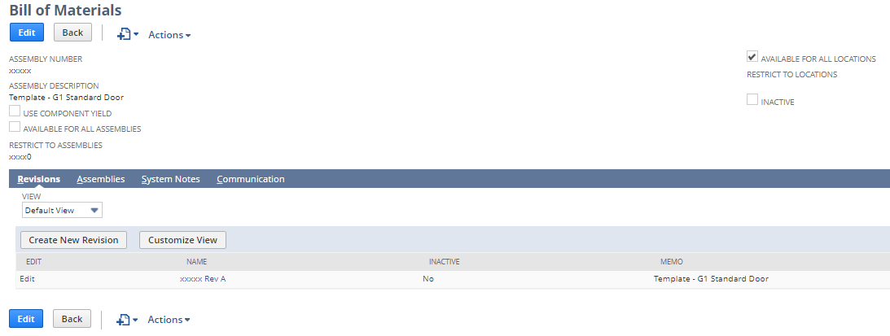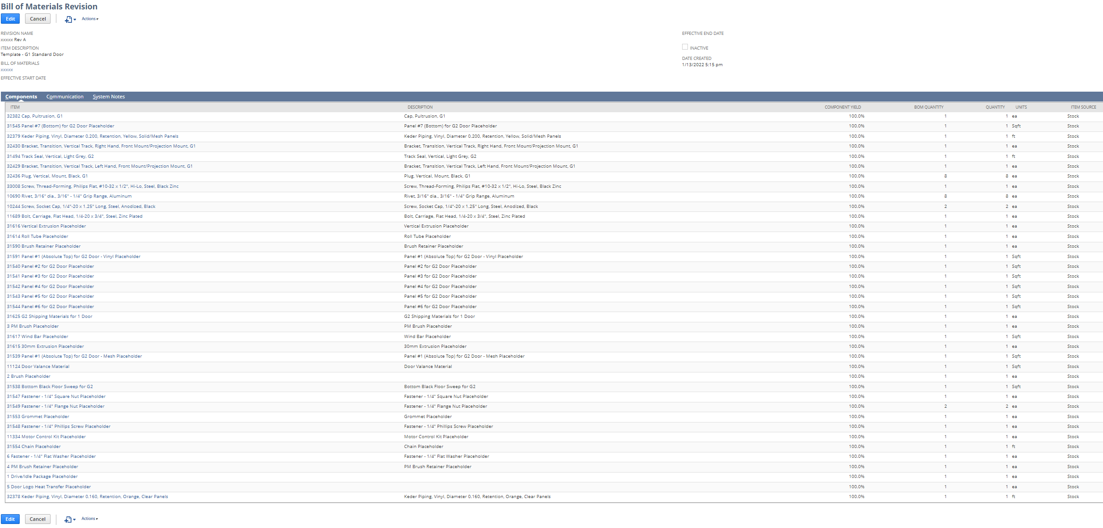
This template is chosen by the selection of the Door Sub-Model Type Question – {DOOR_TYPE}.
From here, we need to determine the components within the BOM. If we look in the Item Name, we can tell the items that are always required VS the items that May be required by looking for the word “Placeholder”. If you don’t see the word Placeholder, that item is required for ALL assemblies. If you do see the word Placeholder, that item may be required, depending on the CPQ conditions.
- Example Static Component Item: 32382 Cap, Pultrusion, G1
  - This component should be added to every single Assembly BOM.
- Example Dynamic Component Item 1: T31591 Panel #1 (Absolute Top) for G2 Door – Vinyl Placeholder
  - This component should be added if the user selected the Vinyl Material {MATL_TYPE/SOLID_18OZ,SOLID_32OZ}.
- Example Dynamic Component Item 2: T31539 Panel #1 (Absolute Top) for G2 Door – Mesh Placeholder
  - This component should be added if the user selected the Mesh Material {MATL_TYPE/MESH_MATL,BIRD_MESH}.
If the user selects Vinyl, we wont need the Mesh option. This component can be removed. The reverse would also be true.
Speaking of Panels, you will see that all the panels have Numbers assigned. We will need to determine how many of those panels will be needed. This will be determined by the style & size. Attached will be an Excel file which will help you to determine these options. Also, the client has set up Images to be displayed in the CPI section based on conditions in the UI. This can also serve as reference.
- Example: An 8’ door only has 4 panels, but a 12’ door has 6 panels.
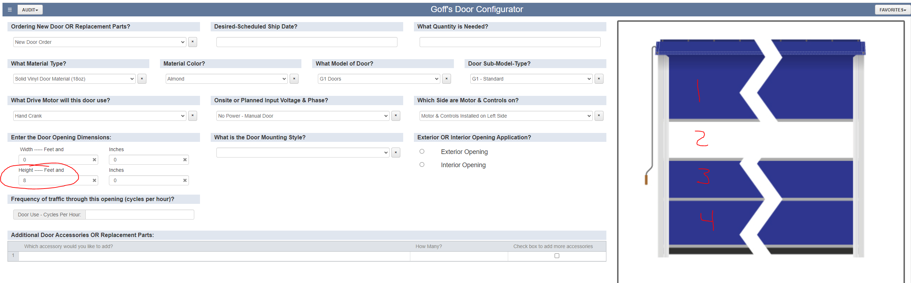
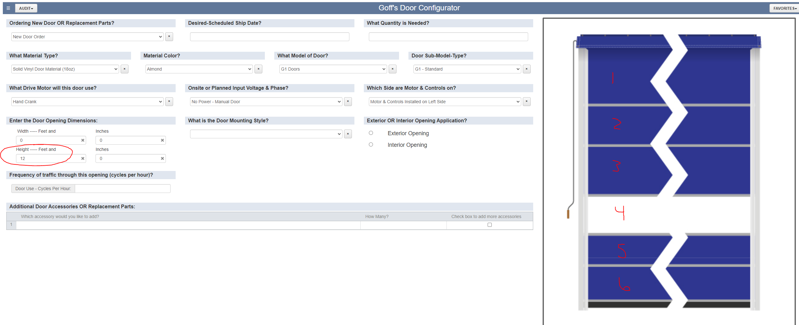
If panels are not required, they can be removed from the BOM.
Quantities of these components are largely determined by the Dimensions. Attached will be another Excel file which will help with these formulas.
In addition to the Assembly Item, it is possible the user will also want to add some accessory items to the order. This will be facilitated by the Additional Door Accessories OR Replacement Parts QTable at the bottom of the UI. The client set up the table to be a Picklist, where the user can select whichever part(s) they may want. The user will select an item {DOOR_ACC/ACC_OPTION_1} & provide the quantity of that item { DOOR_ACC/ACC_QTY_1}. If they want to add more items, they will check the checkbox at the end of the row, making the next row visible. For each item selected in this QTable, they will be individual line items on the transaction.

*Expected outputs.*
- New Assembly Item is created
- Appropriate BOM/Revision is selected/created
- Assembly Items & Accessories output to the transaction line.

*Potential Risks:*
TBD

*Other Notes:*
3 Excel files to use as reference. 1 of those files is the tool they currently use to place orders. Lots of useful information here, as they do look ups in Excel. This is where you can find your formulas for quantities.

